

Centre for Applied Medical Statistics

UNDERSTANDING NON-PARAMETRIC METHODS

PRACTICAL SOLUTIONS

©CAMS
Department of Public Health and Primary Care
Institute of Public Health
University of Cambridge
Forvie Site
Robinson Way
Cambridge
CB2 2SR

Session 1

- What is the main assumption that parametric statistics are based on?
Normality. That is the data are drawn from a population with a normal distribution

- What level of measurement are the following types of data?
The best way to decide what level of measure data is at is to first write down some examples this can make the data type more obvious.

Weight: 56kg, 75kg, 26kg. Weight is measured on a continuous scale, so it can take any value. 0kg is a valid measurement meaning that the object does not weigh anything. Therefore weight is at the ratio level of measurement.

Marital status: Single, divorced, widowed, married. These are all categorical but they have no implicit order to them (although there is a partial ordering), therefore they are at the nominal level of measurement.

Stage of breast Cancer: 1,2, 3a. These are categorical, they are numbers assigned to different categories, however, they have an order to them therefore the data are at the ordinal level of measurement

Number of Children: 0, 1, 5. This is a categorical variable, but it has an ordering, as 2 children is more than 1 child. Therefore, it is an ordinal variable.

Blood Type: A, B, O. These are categorical and have no order to them therefore the data are at the nominal level of measurement.

Mortality rate: 1, 2.35, 0.72. This is a continuous variable; it is possible (although probably unlikely) to have a mortality rate of 0 representing no deaths. Therefore the data is at the ratio level of measurement.

Socio-economic status: I, II, III. This is assigning a category to socio-ecomnomic status, the categories do have an order to them although differences between different categories may differ therefore the data are at the ordinal level of measurement.

- Which type of analysis would you use on the data below, parametric or non-parametric?
To answer this question you need to decide if you think the data are normally distributed enough to use parametric statistics or not. This question does not have a definite answer and two different statisticians may recommend two different things. If there is any doubt about normality and the sample size is small then non-parametric methods are usually the better option. If the sample size is larger then it is not so much of a problem as you “can appeal” to the central limit theorem.

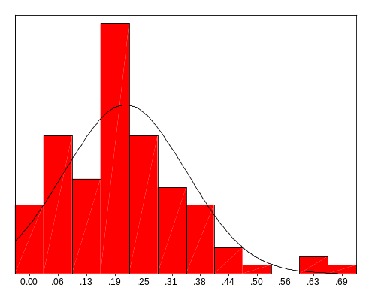

This histogram is slightly skewed. As can be seen from the boxplot below the histogram there are three outlying values, which may bias parametric tests. Looking at the boxplot the left-hand whisker is shorter than the right one suggesting right skewing of the data. Also the median is slightly to the right of the box also suggesting skewing.

However, if the sample size is large these three outlying values should not affect parametric tests too much so they maybe OK to use.

In the analysis that was carried out on these data non-parametric methods were used.

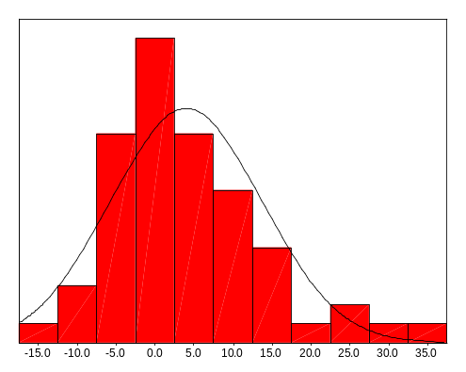

This histogram is less skewed than the first. Looking at the boxplot the two whiskers are of more equal length, although the median is not in the middle of the box. However, this data is probably not skewed enough to worry about so parametric methods could be used, particularly if the sample size is large.

The analysis on this data was carried out using non-parametric methods. This was because some of the other variables in the analysis were a lot more skewed so non-parametric methods were used for consistency.

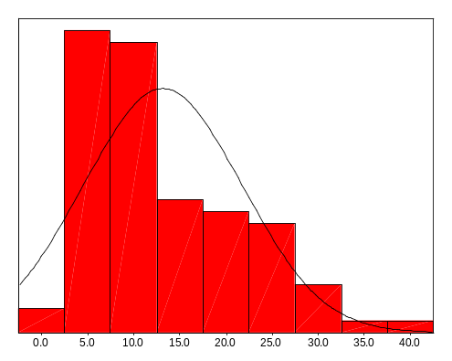

As can be seen from the histogram the data are left skewed. This can also be seen from the boxplot, as the left whisker is shorter than the right one. The boxplot also shows that the median is shifted to the left and there is one outlying data point. This would suggest the use of non-parametric methods. It may be possible to log transform the data to remove the

skewing and then use parametric methods if the sample size is large enough.

When this data was analysed it was analysed non-parametrically. A log transform was attempted but the data became bi-modal.

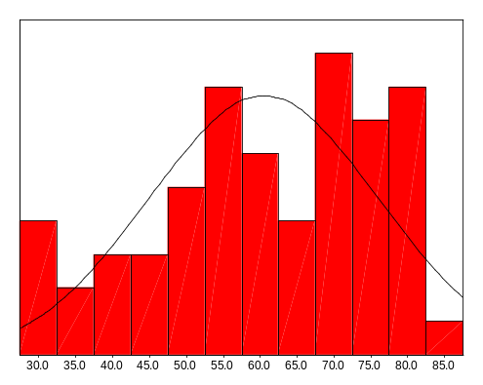

These data are clearly not normally distributed. It is possible that they are from a combination of two normal distributions. This data is outcome data from two different groups and this may represent the two different distributions. The boxplot shows that the data are right skewed, as the left whisker is longer than the right whisker. The median in this case is in the centre of the box, but the box is skewed to the right.

In the actual analysis these data were analysed non-parametrically, as the data were not normally distributed even once split by the two groups.

- Name some situations that suggest the use of non-parametric methods.
When the independent and/or dependent variables are nominal in measurement
When the data are ordered with many ties
When the data are rank ordered
When there is a small sample size
When the dependent variable has a distribution other than normal
When the groups have unequal variances
When there are unequal pairwise correlations across repeated measures
When the data has notable outliers

- Describe the two types of alternative hypothesis.
Two-sided and one-sided.

A two-sided alternative hypothesis can go either side of the null value, a one sided states higher, or lower but not both.

One-sided alternative hypotheses are rarely used; in most cases a two-sided hypothesis is to be preferred. If a one-sided test is used it should be clearly stated why it has been used.
Session 2

- Calculate Spearman’s rank correlation coefficient for this data (data from Sanjana Nyatsanza, Fulbourn hospital). Is there are correlation between NPI and stereo (stereotypical behaviour total score).

It is usually best to carry out the calculations in a table (as below). Firstly rank NPI total. Assign the average rank for any ties. Next rank stereo total. It does not matter if you start with the lowest or the highest as long as the same is done for both variables. Then calculate the difference between the ranks (rank diff). Then square the differences between the ranks (d²). Then add up all the squared differences between the ranks (sum).

NPI total | Rank | Stereo total | Rank | Rank diff | d²
4 | 4.5 | 16 | 3 | 1.5 | 2.25
12 | 8 | 61 | 8 | 0 | 0
12 | 8 | 74 | 10 | -2 | 4
12 | 8 | 54 | 5.5 | 2.5 | 6.25
3 | 3 | 57 | 7 | -4 | 16
0 | 1.5 | 7 | 2 | 0.5 | 0.25
12 | 8 | 54 | 5.5 | 2.5 | 6.25
0 | 1.5 | 0 | 1 | 0.5 | 0.25
4 | 4.5 | 17 | 4 | 0.5 | 0.25
12 | 8 | 62 | 9 | -1 | 1
 |  |  |  | Sum | 36.5

Then substitute the values into the equation, where Σd² is the sum, and n is the number of subjects (in this case 10). Then calculate the coefficient as below.

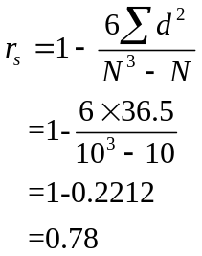

Calculate the 95% confidence interval:
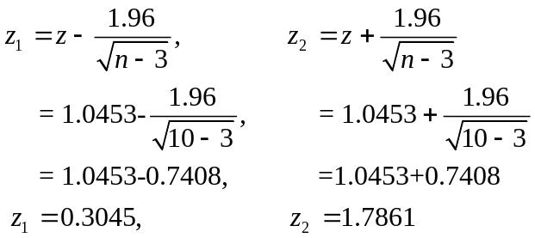
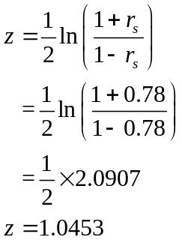
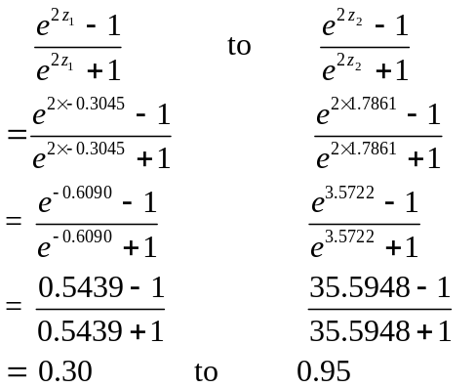

Therefore, r_{s}=0.78 (0.30, 0.95)

- Calculate the kappa coefficient for the agreement between the treatment step and symptom step shown in the table. Treatment step is the step of the asthma guidelines that a patient’s treatments indicate them to be on. Symptom step is the step of the asthma guidelines that a patient's symptoms indicate them to be on. The level of agreement indicates how good doctors are at treating asthma.

Here most of the work is in working out which bits go where in the equations. It is best to work out the proportion of chance agreement and the proportion of expected agreement first and then put them into the kappa formula.

Treatment step
Symptom step |  | 1 | 2 | 3 | 4 | Total
Symptom step | 1 | 54 | 47 | 13 | 15 | 129
Symptom step | 2 | 29 | 29 | 9 | 4 | 71
Symptom step | 3 | 29 | 24 | 8 | 4 | 65
Symptom step | 4 | 1 | 0 | 0 | 0 | 1
Symptom step | Total | 113 | 100 | 30 | 23 | 266

Putting the numbers into the formula gives:

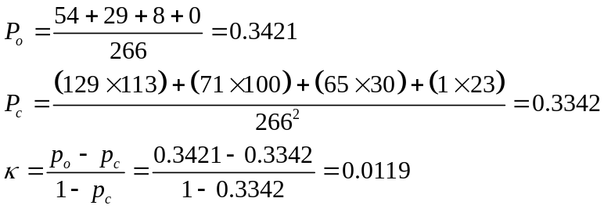

Therefore, κ = 0.01, which according to Altman’s table is poor level of agreement.

Calculate the 95% confidence interval:

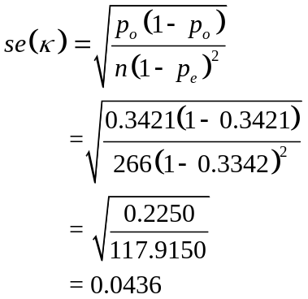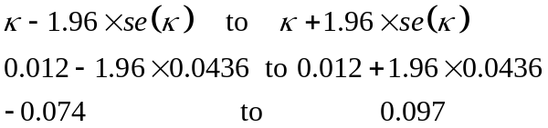

κ=0.01 95% CI (-0.074, 0.097)

- Calculate the chi-square statistic for the table below to see if fibrosis stage is associated with alcohol consumption. Are all the assumptions of the chi-square test met? Is the chi-square statistic significant at the 5% level?

Fibrosis stage | Alcohol |  | Total
Fibrosis stage | <80g/day | >80g/day | Total
0 | 6 | 6 | 12
1-3 | 32 | 21 | 53
4,5 | 11 | 10 | 21
Total | 49 | 37 | 86

First we check that all the assumptions of the chi-square test are met:
The data are frequencies and not scores.
The two variables are categorical with mutually exclusive levels.
The observations are independent of each other.
All expected counts exceed 5.

Therefore all the assumptions are met and it is OK to use the chi-square test. Next calculate the expected values in each cell:

(12x49)/86 = 6.837 | (12x37)/86 = 5.163
(53x49)/86 = 30.198 | (53x37)/86 = 22.802
(21x39)/86 = 11.965 | (21x37)/86 = 9.035

Next plug these numbers into the formula:
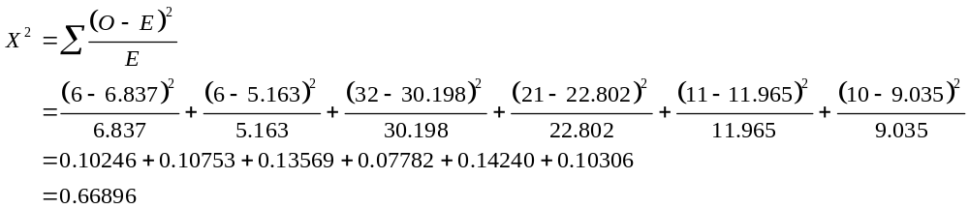

The degrees of freedom = (number of rows – 1) x (the number of columns – 1)

= (3-1) x (2-1) = 2.

Looking up χ²₂ at the 5% significance level in the tables we find that χ²₂ = 5.99.

X² = 0.67 < 5.99 = χ²₂

Therefore the chi-square statistic is not significant at the 5% level of significance. In fact the p-value for this test is (0.72 which is greater than 0.05 by some way).

Session 3

- Two different methods have been used to stain cells in tissue samples from people with cancer (data part of a set from Jamie Sington, Pathology dept). Each person’s tissue sample has been stained by both methods. After staining the number of abnormal cells counted. These counts are listed in the table below.
- Use and name the appropriate non-parametric method to see if there is a difference in cell count between the two methods.
- Write a sentence to report the results of the test.
- Explain why you have chosen the method that you used.

MCM | KI-67
14.78 | 14.78
7.96 | 8.68
10.89 | 1.57
12.10 | 1.85
18.23 | 5.84
16.40 | 3.04
18.02 | 3.96
23.35 | 8.16
26.70 | 8.40
14.78 | 14.78

The data are paired as each sample has two different measurements one for MCM and one for KI-67. Therefore the Wilcoxon signed rank test will be used. First find the difference between the MCM and KI-67 value on a sample (difference). Then rank these differences. Then determine the sign of the difference (whether the difference was positive or negative (sign)).

MCM | Ki-67 | Difference | Rank | Sign
14.78 | 14.78 | 0 | - | =
7.96 | 8.68 | -0.72 | 1 | -
10.89 | 1.57 | 9.32 | 2 | +
12.10 | 1.85 | 10.25 | 3 | +
18.23 | 5.84 | 12.39 | 4 | +
16.40 | 3.04 | 13.36 | 5 | +
18.02 | 3.96 | 14.06 | 6 | +
23.35 | 8.16 | 15.19 | 7 | +
26.70 | 8.40 | 18.3 | 8 | +
14.78 | 14.78 | 0 | - | =

Next calculate the sum of the positive and negative ranks. This gives W⁺ = 35 and W⁻=1. There are 8 differences therefore N=8. Min (W⁺, W⁻) = 1. From the tables (N=8, α=0.05) the critical value is 3. 1<3 therefore there is sufficient evidence to reject the null hypothesis.

Using the Wilcoxon Signed rank test shows that there is a significant difference in cell count between the MCM (Md=15.6) and Ki-67 (Md=7.0) groups (p=0.016).
The test was used because the data were paired. Of course the assumption that there is symmetry of the differences around the true median should be checked. If this assumption is violated then the sign test should be used.

- In the following situations which is the appropriate test to perform. Give reasons for your choice of test.

- The average daily energy intake over ten days of 11 women is recorded. The recommended level of energy intake is 7725kJ a day. The average intake of all the women is to be compared to the recommended intake of 7725kJ per day.

The easiest way to look at this would be to look at each woman’s daily intake and see whether it was above or below 7725kj and use the sign test.

- In a study of the risk of coronary artery surgery to women, the median duration of intubation is be compared between two groups older and younger women.

The data are not paired and medians are being looked at so the median test could be used. Or the Mann-Whitney U test if the assumption of similar distributions is met.

- In a trial to test whether a drug is a diuretic or not there are two treatment arms, placebo and drug. The daily urine production is measured in both groups. The amount of urine produced is to be compared between the two groups.

The data are not paired and two groups are being compared so the Mann-Whitney U test could be used or the Median test. Depending on the null hypothesis to be tested, if a difference in medians is being looked at then the assumption of similarity of distributions needs to hold for the Mann-Whitney U test to be used.

- The reaction times of pairs of twins are to be tested. Each twin in the pair will be randomly assigned to group A or group B. Group A will remain sober and group B will drink three double whiskies. After their drinks their reaction times will be tested and compared.

This study is on twins therefore the data are paired. The length of reaction time is important therefore the Wilcoxon signed ranks test would be preferred to the sign test if the assumption of symmetry about the true median difference holds. Otherwise the sign test would be used.

- A study is to be carried out to test whether hormone levels effect how quickly caffeine is eliminated by the body. There will be three arms to the trial, males, females on the contraceptive pill and females not on the contraceptive pill. Each subject will be given a tablet that contains 250 mg of caffeine. The half-life of the caffeine in the blood will then be measured. These half-lives will then be compared between the three groups.

The data are not paired there are independent samples. There are more than two groups. The length of time might be important. Therefore, the Kruskal-Wallis test would be preferred to the median test. Depending what null hypothesis is being tested. If the difference in medians were being tested then the assumption of similarity of distributions would need to hold to use the Kruskal-Wallis test. Otherwise, the median test should be used. If the shape and distribution of the groups were important then the Kruskal-Wallis test would again be preferred.

- Dr D. R. Peterson of the Department of Epidemiology, University of Washington, collected the following data. It consists of the birth-weights of each of 20 dizygous twins. The hypothesis to be tested is that the SIDS child of each pair has a lower birth-weight.
- Construct the null and alternative hypothesises

H₀: There is no difference in birth-weight between the two sets of twins.
H_{A}: The SIDS child of each pair has a lower birth-weight.

- Decide on the level of significance to be used and whether the test should be one-sided or two-sided.

α=0.05. One-sided test as H_{A} is directional.

- Carry out the sign test to test the null hypothesis at the level of significance decided upon.

To use the sign test decide the sign of the difference between the twins:

SIDS | Non-SIDS | Sign of difference
1474 | 2098 | -
3657 | 3119 | +
3005 | 3515 | -
2041 | 2126 | -
2325 | 2211 | +
2296 | 2750 | -
3430 | 3402 | +
3515 | 3232 | +
1956 | 1701 | +
2098 | 2410 | -
3204 | 2892 | +
2381 | 2608 | -
2892 | 2693 | +
2920 | 3232 | -
3005 | 3005 | =
2268 | 2325 | -
3260 | 3686 | -
3260 | 2778 | +
2155 | 2552 | -
2835 | 2693 | +
Next count the number of positives, +ve = 9. The number of negatives -ve = 10. The number of ties, ties = 1. Add the number of positives and negatives to give N.
 N=19.

- Is there is significant difference between the birth-weights?
Look up N=14, P=0.5 x=9 in the binomial tables. Pr=0.5>0.05 therefore there is not sufficient evidence to reject the null hypothesis of no difference in birth-weight between the two groups.

- Write a sentence to report the results of the test.

The results of the sign test show that there is no significant difference in birth-weight (p=0.5) between the SIDS twins (Md=2864) and the Non-SIDS twins (Md=2722).

Session 4

- In a study on caesarean sections (Frame et al 1985) the maternal shoe size is a variable collected. The chi-square test is used to see if there is an association between maternal shoe size and caesarean section. Studying the SPSS output below

 | Value | df | Asymp.  Sig.  (2-sided)
Pearson Chi-Square | 9.287ª | 5 | 0.098
Likelihood Ratio | 9.344 | 5 | 0.096
Linear-by-Linear  Association | 7.887 | 1 | 0.005
N of Valid Cases | 351

- The ordinary chi-square test statistic in the table tests the null of hypothesis of no association between the variables. Interpret the results of this test.

The chi-square test shows that there is no association between maternal footsize and whether there has been a caesarean section or not (p=0.098).

- The chi-square test for trend is also shown in the table. What result does it suggest?

There is strong evidence of a linear trend in the proportion of women giving birth by caesarean section in relation to shoe size.

- Can you suggest a reason for the discrepancy in these results?

The difference between the groups is due to a linear trend. The ordinary chi-square test does not test for a trend. Therefore, the results were not significant. Alternatively the sample size may not have been big enough to detect the association but was big enough to detect the trend.

After carrying out a chi-square test, you notice that SPSS has produced the following warning:

- 3 cells (37.5%) have expected count less than 5. The
minimum expected count is 0.70.

- What impact does this have on the results?

This means that one of the assumptions of the chi-square test has been violated. Therefore, it is inappropriate to carry out a chi-square test.

- What could be done to overcome this problem?

It is possible to combine some of the categories. This may mean that the expected counts of the relevant cells are larger and may make them large enough to use the chi-square test. Otherwise Fisher's exact test would have to be used.

- During the trial of a new drug the number of times that patients had to take medication for pain was noted. The pairs of histograms below show these numbers for the treatment and control arms. For each pair say which test you would use and why.

a.
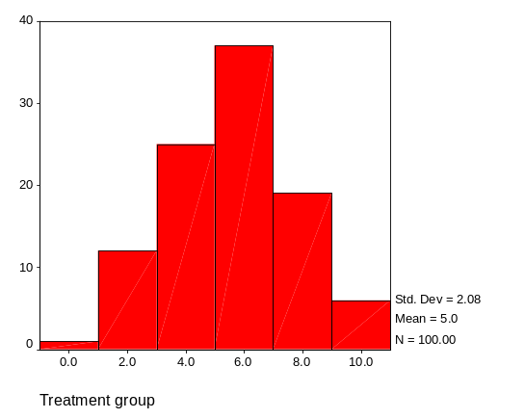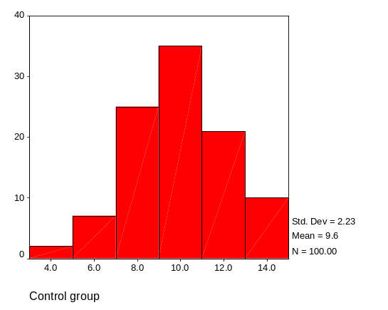

Both of the histograms are fairly normally distributed therefore the t-test could be used. The data are not paired therefore it would be the independent samples t-test.

b.
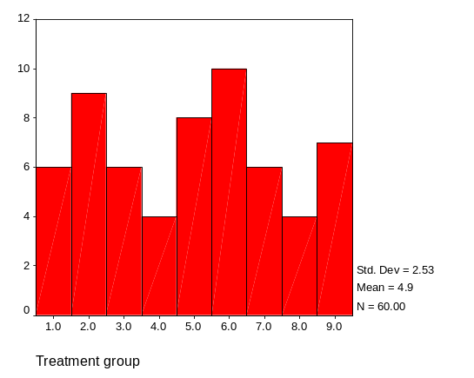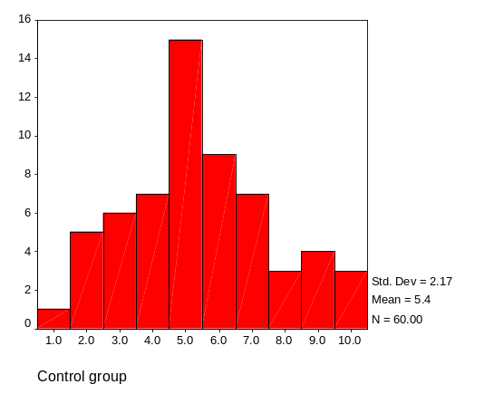

The data are not paired. Neither histogram is normally distributed. The two histograms are distributed differently therefore the median test would be used.

c.
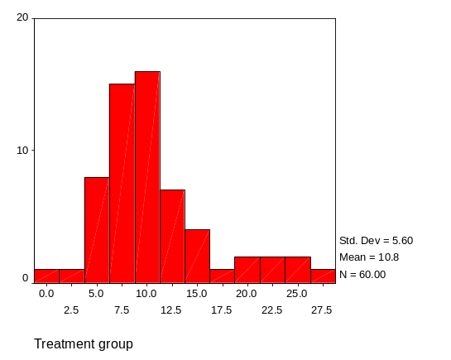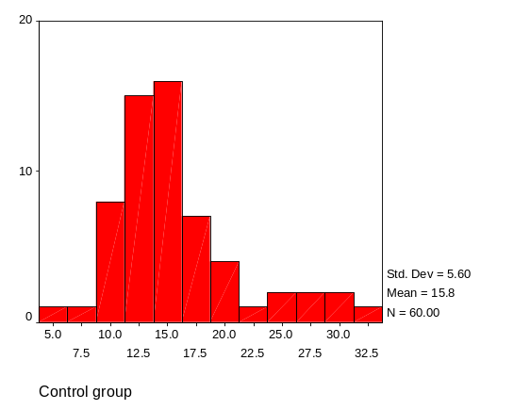

The data are not paired. Both histograms are skewed but similarly distributed therefore the Mann-Whitney U test would be used.

- In 1972, Wilding and Meddis tested a suggestion that extroverts would be less susceptible to motion sickness than introverts would. In a small pilot study, they administered Reason’s motion sickness questionnaire (MSQ) and Eysenck’s personality inventory (EPI) to a class of 22 young psychology undergraduates. The results of the Spearman’s rank test are shown in the table below.

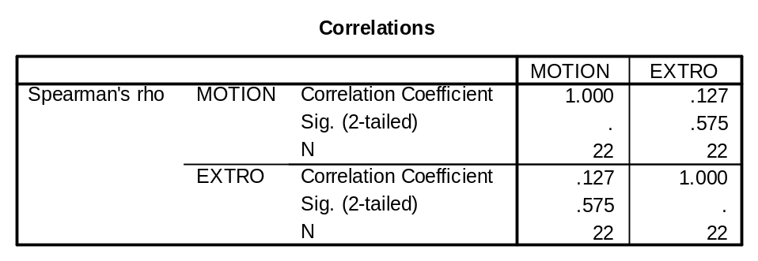

- Write a sentence to report the results of the analysis.

Spearman’s rank correlation coefficient shows that there is no significant correlation between motion sickness and extroversion (R_{S}=0.127, p=0.575).

Analysis in another package gives the 95% confidence interval for the Spearman’s rank correlation coefficient as (-0.29, 0.54).

- Rewrite the sentence reporting the results including this confidence interval.

Spearman’s rank correlation coefficient shows that there is no correlation between motion sickness and extroversion (R_{S}=0.127 (-0.2929, 0.5459)).

The confidence interval is consistent with this finding.
- Does the confidence interval change your opinion about the association between the two variables? Explain your answer.

No, although the confidence interval is wide it does not change the conclusion.

- Explain why it is better to give a confidence interval around a correlation coefficient than to quote a p-value.

A confidence interval gives the range of values that are consistent with the data not just whether it is significant or not.

- The aim of a study was to compare a radioallergosorbent (RAST) test and a multi-RAST (MAST) test on sera for specific IgE as a test of allergy in subjects for whom the skin prick test cannot be used. The MAST was a new simpler and cheaper test. The agreement matrix for the two tests is shown below.

Count
 | RAST |  |  |  |  | Total
 | 1 | 2 | 3 | 4 | 5 | Total
MAST 1  2  3  4  5  Total | 86  26  20  11  3  146 | 3  2  1  6 | 14  10  22  37  15  98 | 4  4  16  24  48 | 2  1  14  48  65 | 105  40  49  79  90  363

- Underline the values in the table that represent agreement between the two tests.

- Does it look as if there is likely to be a good level of agreement between the two tests? Justify your answer.

There are some reasonable numbers on the diagonal but there are some numbers off the diagonal that are larger than those on the diagonal maybe moderate agreement.

The output for the kappa coefficient for agreement between the two tests is shown below.

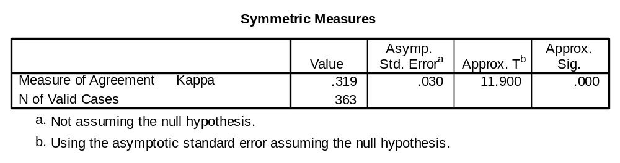

- Rate the agreement between the two tests.

Looking κ=0.319 up in Altman’s table shows that the agreement is in the fair category.

- Write a sentence reporting the results of the tests.

Using a kappa coefficient shows that there is a fair level of agreement between the MAST and RAST tests.

- Would you recommend replacing the RAST with MAST? Justify your answer.

No the agreement would have to be a lot stronger to replace one with the other. Also kappa is not the correct analysis to decide this a limits of agreement analysis should be carried out.

The 95% confidence interval around the kappa coefficient is (0.25, 0.39).

- Does this change the rating of the agreement between the two tests?

No, the whole of the confidence interval falls within the fair category.

- Why would you quote a 95% confidence interval around the kappa coefficient rather than the p-value given in the SPSS output?

P-value tests the difference from zero, which is not informative. The confidence interval gives more information about the data.

